**Cool/helpful extensions from Visual Studio Code**

Auto Rename Tag

Code Autocomplete

Indent-rainbow

Prettier

Live Preview / Live Server

Colorize

Bracket Pair Color

Vscode-icons

Relative Path

Path Intellisense

### **Auto Rename Tag**

Rename your opening tag and your closing tag will follow suit, vice versa

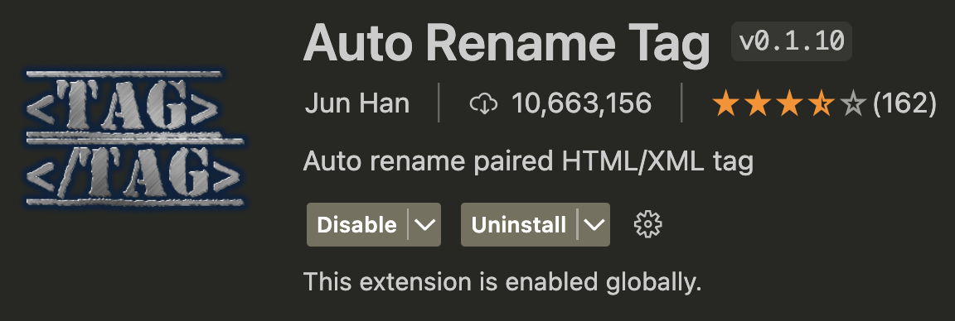

### Code Autocomplete

AI to suggest code for auto completion

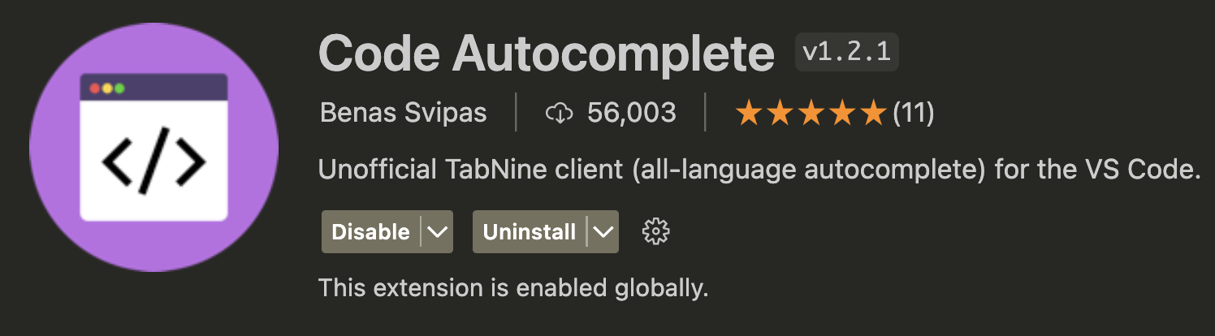

### Indent-rainbow

Visualize indents easier with colours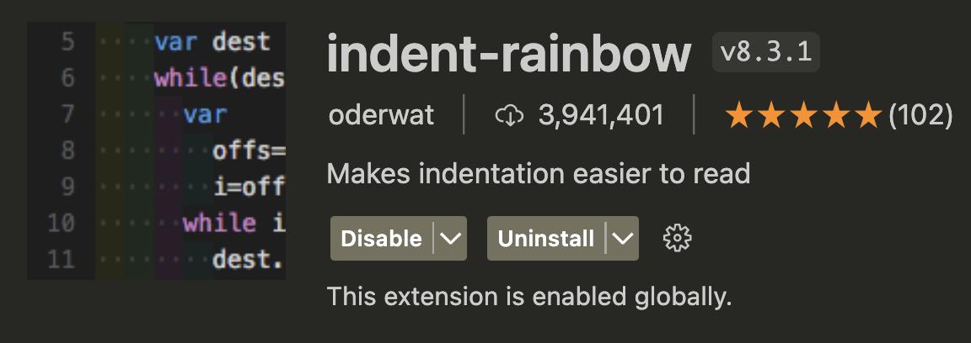

### Prettierx

Visually appealing colours for different codes for easy viewing

### Live Preview / Live Server

View your webpage beside your code with live changes



### Colorize

Highlight a colour hex or rgb in the css portion to view the colour as the highlight

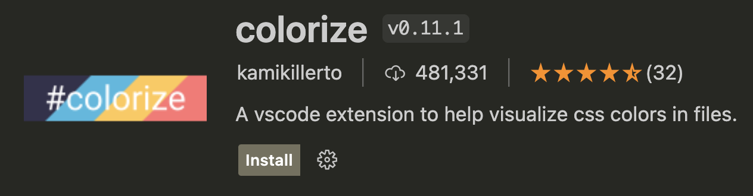

### Bracket Pair Color

Different colours for different brackets



### Vscode-icons

Icons for your explorer for aesthethicc purposes

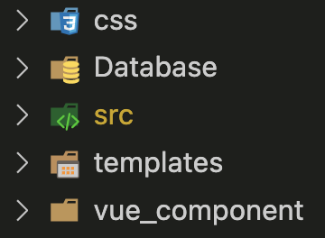

### Relative Path

Copy relative paths easily from the explorer

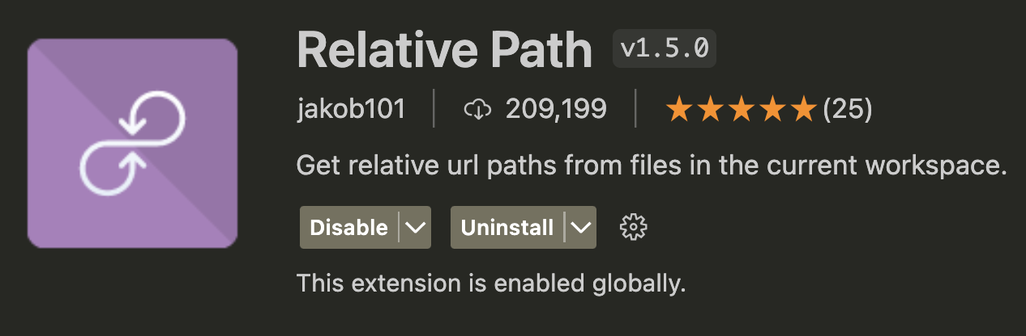

### Path Intellisense

Autocomplete file names - will detect file names as you type the first few letters

